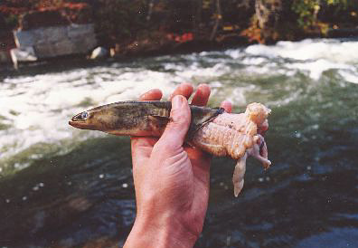

Score:

Hydro electric turbine blades 1
American eel 0
Photo: Watts Brothers

